**Setting Up Amazon Bedrock Access**

To begin, enter **Bedrock** in the AWS Management Console search box. Then from the results, choose **Amazon Bedrock**.

On the Amazon Bedrock **Overview** page, choose **View Model catalog**.

On the **Model catalog** page, a full listing of models that you can use with Amazon Bedrock is displayed. You can use the **Filters** panel to explore the various models.

After you have explored the model catalog, scroll to the end of the side navigation panel and choose **Model access**. Note that if there are new models available for your account, they are listed next to the **Model access** link. Requesting access to additional models requires administrative access to your account.

By default, all available models will be selected in the **Edit model access** panel. If you do not want access to any specific model, clear the checkbox for that model.

Scroll to the end of the page, and choose **Next**.

On the **Review and submit** page, you can verify that the desired modification has been selected. If you want to change any of your selections, choose **Edit**.

Then scroll to the end of the page. The terms for any models that you have chosen are displayed. Review them, and then choose **Submit**.

After the access request is processed, you can access the additional models. The **Access status** will change to **Access granted**.

**Configuring Model Parameters in a Playground Session**

On the AWS Management Console, enter **Bedrock** in the search box. Then from the search results, choose **Amazon Bedrock**.

From the side navigation panel, under **Playgrounds**, choose **Chat / Text**.

In the chat playground panel, choose **Select model**.

The **Select model** dialog box appears. From the **Categories** column, choose a model provider. Then, from the **Models** column, choose an available model from the provider that you selected. Then choose **Apply**.

In the **Configurations** panel of the chat playground, scroll to the **Randomness and diversity** section.

Leave **Temperature** and **Top P** set to their default values. These settings tell the model how creative it can be in its responses. A table below summarizes how these settings affect generated content.

Then, in the **Write a prompt** input box, enter the following: **Write a short story about a day in the life of an extraterrestrial visiting Earth for the first time.** You will run the same prompt three more times in this demonstration. Choose **Run**.

The generated response is displayed. There are two options for copying text from the chat playground. The first is available outside of the prompts and responses. It will copy the entire conversation to your system’s clipboard. The second is available in each individual response panel, and copies that response to the clipboard.

Now leave **Temperature** set to 1 and adjust **Top P** to 0.1. Paste the short story prompt into the **Write a prompt** text box. Then choose **Run**.

Next, set **Temperature** to 0.2 and **Top P** to 0.9. Paste the short story prompt into the text box. Then choose **Run**.

Now, leave **Temperature** at 0.2 and set **Top P** to 0.1. Paste the short story prompt into the text box. Choose **Run**. You have generated four variations of the short story. The stories generated in this demonstration are available following the transcript of this video. Compare the different versions to see how the settings affected the creativity and predictability of each version.

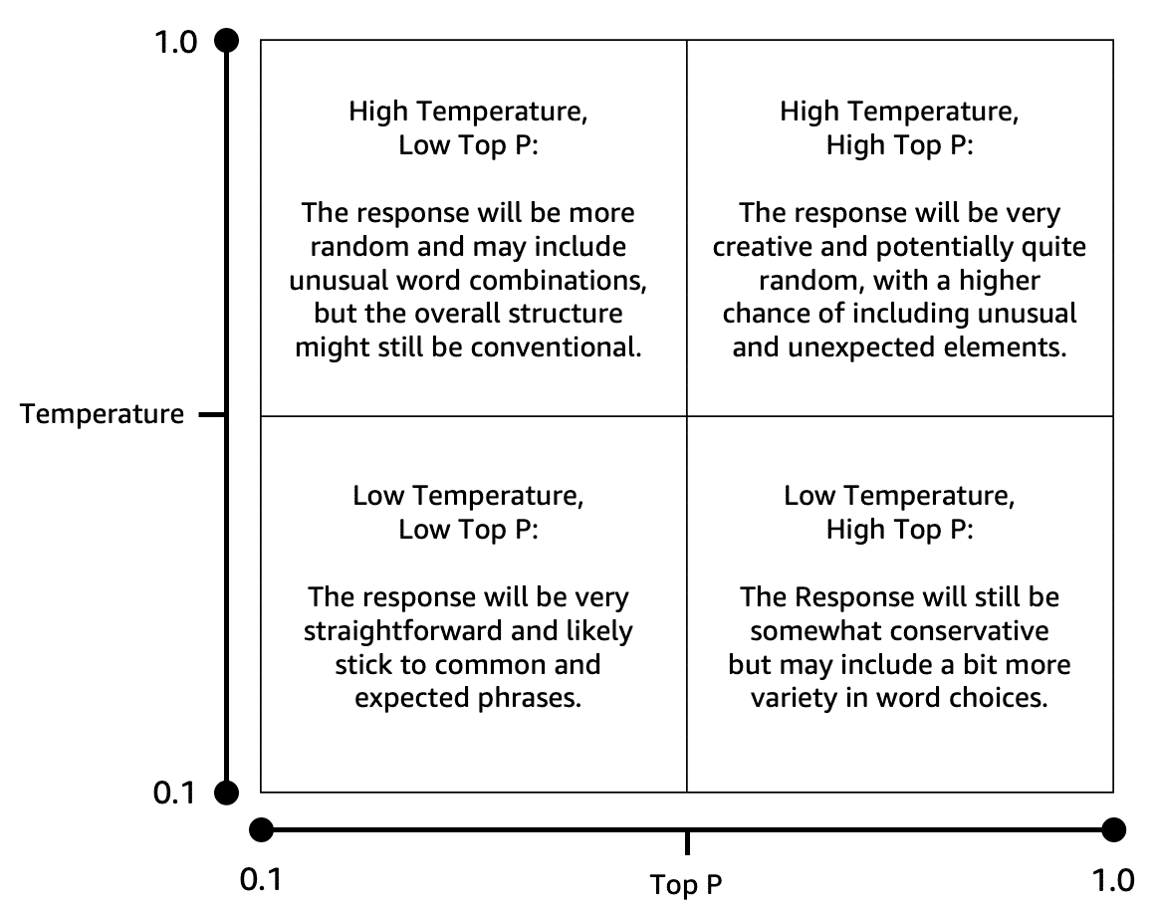

**Creating Your First Amazon Bedrock Knowledge Base**

On the AWS Management Console, enter **Bedrock** in the search box. Then from the search results, choose **Amazon Bedrock**.

From the side navigation panel, choose **Knowledge Bases**.

On the **Knowledge Bases** page, choose **Create**. Then choose **Knowledge Base with vector store**.

On the **Provide Knowledge Base details** page, enter a name in the **Knowledge Base name** text box.

Then scroll to the **IAM permissions** section. Select the radio button next to **Create and use a new service role**. Verify that Amazon S3 is selected as your data source.

Then, scroll to the end of the page. Choose **Next**.

Now, on the **Configure data source** page, enter a name for your data source.

Then, scroll to the **Content chunking and parsing** section. Leave the settings at their default values. Choose **Next**.

On the **Configure data storage and processing** page, from the **Embeddings model** section, choose **Select model**.

On the **Select model** pop-up window, choose a model provider and model. Then choose **Apply**.

Scroll to the **Vector store** section. For **Vector store creation method**, verify that **Quick create a new vector store** is selected. Then choose **Next**.

Now, verify the options that you have set.

Scroll to the end of the page. Choose **Create Knowledge Base**.

After 2 to 3 minutes, the **Knowledge Base overview** page appears. Choose its name from the **Data source** panel.

In the **Documents** section, choose **Add documents**. Then choose **Add document directly**.

Enter a document identifier, and verify that **Upload** is selected. Then choose the **Choose file** button.

Navigate to where you have the file saved. Select it, then choose **Open**.

Add additional documents, if you want. Then choose **Add**.

A progress banner appears to let you know that ingestion has begun. This process can take 2 to 30 minutes, depending on the volume of data that you have uploaded.

When the ingestion process has finished, a success banner appears. From the side navigation panel, choose **Knowledge Bases**.

Select the checkbox next to the name of your data source. Then choose **Sync**.

After a few minutes, a success banner appears, to confirm that the sync operation finished. Choose **Test Knowledge Base**.

On the **Test** page, from the **Retrieval and response generation** section, choose **Select model**.

In the **Select model** pop-up window, select a model provider, then a model. Choose **Apply**.

Enter a simple prompt requesting information that is found in your data source. For this example, the prompt asks for a description of the differences between few-shot and zero-shot prompting. This topic is covered on pages 625 through 627 of the PDF provided for this demonstration. Use the send icon to submit the prompt.

A response is generated. To understand how your selected model created the response, choose the **Details** link that follows the response.

Now the **Details** panel is displayed, with information regarding how the response was generated. To close the test panel and return to the landing page for this Knowledge Base, choose **Close**.

**Deleting Resources**

To begin, return to the Amazon Bedrock console. From the side navigation panel, choose **Knowledge Bases**.

Select the radio button next to your Knowledge Base. Then, choose **Delete**.

A **Delete Knowledge Base** pop-up window appears. Enter **delete** in the text box to confirm the operation. Then, choose **Delete**.

A banner appears, to confirm that deletion of the Knowledge Base is in progress.

When the deletion is complete, your Knowledge Base is no longer listed.

Next, enter **S3** in the console search box. From the search results, choose **S3**.

Choose the name of the bucket that houses your Knowledge Base documents.

Then, select the checkbox next to any documents that you want to remove. Choose **Delete**.

In the confirmation text box, enter **permanently delete**. Then choose **Delete objects**.

A success banner confirms that the document has been deleted.

Go to Amazon OpenSearch console ---> From the left panel go to Serverless --> Collections --> Select the collection --> From the right top , click on Delete and delete the collection .

Also, Navigate to the Domains section 🡪 Select the evidence-read-replica domain and choose Delete.